Problem Statement
Write a Java program to demonstrate the use of the super keyword in inheritance.
Name of Student: Husam Ali Abdalla Nour | PRN:25070122086
Semester: III | Year : AY 2026-27
Subject: Programming with Java
ASSIGNMENT No : 8
TITLE : Super Keyword in Java

Learning Objectives
To demonstrate the use of the super keyword for accessing parent class members.

Programme
class outher
{ private String message=(" haiga mon ame soeur tu es sous la protection
divine"); class inner
{ public String m=(" this is in inner class");
void display()
{
System.out.println("here is inside the display");
}
void show()
{ System.out.println("message is :"+message);
System.out.println("message :"+m);
System.out.println("ici c est la partie de show");
}
}
}
class animal
{ void sound()
{
System.out.println("make sound beaucoup"); }
}
public class InnerAnonymousDemo
{ public static void main(String[] args) {
outher a = new outher();
outher.inner in = a.new inner()
{ void display()
{
System.out.println("haiga"); super.display();
} void show()
{
System.out.println("fatime"); super.show();
} }; in.display();
in.show();
animal s = new animal()
{
void sound()
{
super.sound();
System.out.println(" c est ici");
} };
s.sound();
}
}

Output
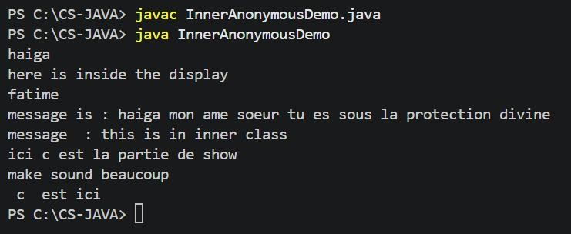

Conclusion
In conclusion, this assignment demonstrated the use of the super keyword in Java inheritance. The super keyword allows a child class to access members of its parent class, such as variables, methods, and constructors. Through this program, we understood how super helps in accessing parent class members and makes inheritance easier to implement and understand.

